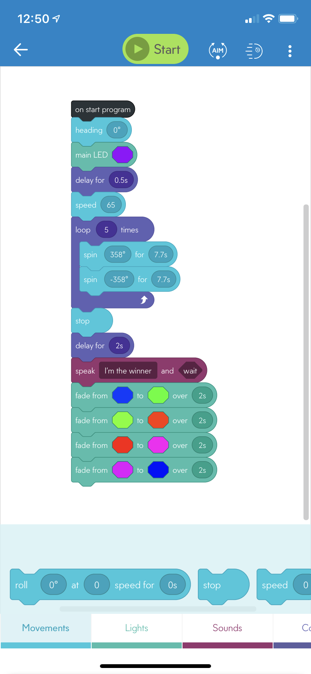

setHeading(0);

setMainLed({ r: 150, g: 0, b: 255 });

await delay(0.5);

setSpeed(65);

for (var _i0 = 0; _i0 < 5; ++_i0) {

await spin(358, 7.7);

await spin(-358, 7.7);

await delay(0.025);

}

stopRoll();

await delay(2);

await speak('I’m the winner', true);

await fade({ r: 6, g: 58, b: 255 }, { r: 53, g: 255, b: 11 }, 2);

await fade({ r: 108, g: 255, b: 0 }, { r: 255, g: 53, b: 0 }, 2);

await fade({ r: 255, g: 12, b: 0 }, { r: 255, g: 0, b: 245 }, 2);

await fade({ r: 228, g: 0, b: 255 }, { r: 0, g: 17, b: 255 }, 2);

}